Assessment Task 2: Movie Ticket Booking System

This program is my implementation of a **Movie Ticket Booking System**, designed to fulfill the requirements of a multi-stage assignment that evaluates the use of switch statements, arithmetic operations, user input handling, and conditional logic. The system calculates ticket costs based on user selections, applies bulk discounts, and optionally includes snack charges.

The code has been developed incrementally to meet the full mark criteria (70–100) by integrating a menu-driven interface, validation mechanisms, and detailed output formatting.

# Basic Ticket Price Calculation System:

Created default values for:

* movieType (Default: 'A' for Action)
* ticketCategory (Default: 'R' for Regular)
* Used a switch statement to calculate base prices:
* Action: £10 (Regular), £15 (Premium)
* Comedy: £8 (Regular), £12 (Premium)
* Drama: £7 (Regular), £10 (Premium)
* Displayed default values and ticket price.

**Implementation code:**

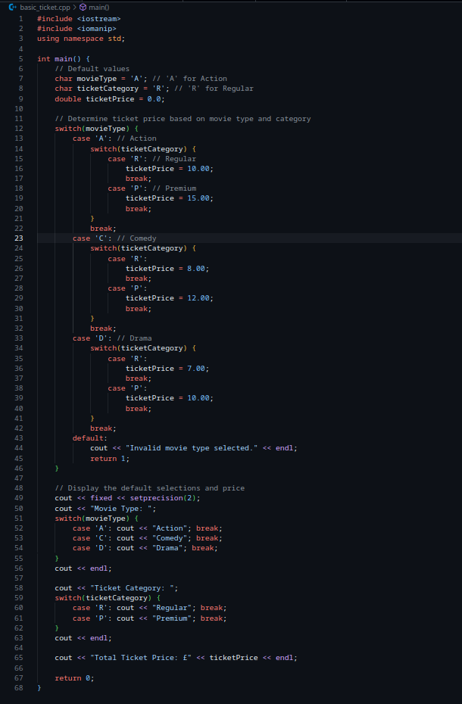

Example output:

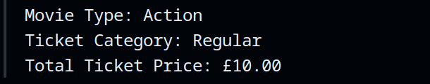

# User Input Functionality

* Modified the program to accept user input:  
  + Movie type: 'A', 'C', 'D'
  + Ticket category: 'R', 'P'
  + Number of tickets
* Used a switch statement to determine ticket price.
* Calculated total cost by multiplying price by quantity.
* Displayed all user inputs and total cost.

**Implementation code:**

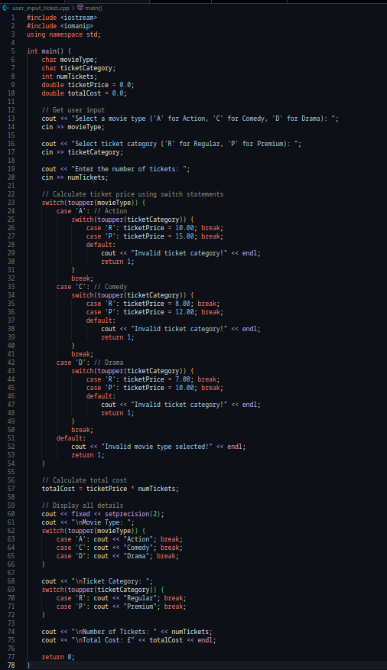

**Example Output:**

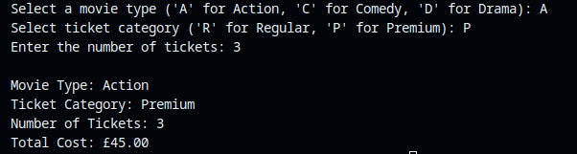

# Discounts and Optional Services

* Implemented a bulk discount of 10% for more than 5 tickets.
* Added a snack service option costing £5 per ticket if selected.
* Displayed a detailed cost breakdown including:  
  + Base total
  + Discount
  + Snack cost
  + Final total

**Implementation code:**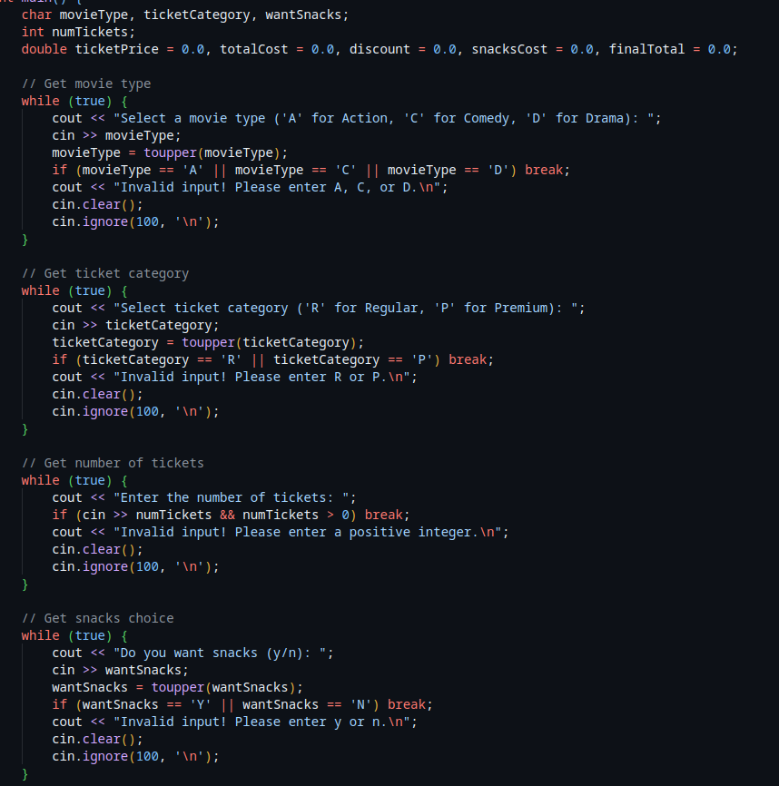

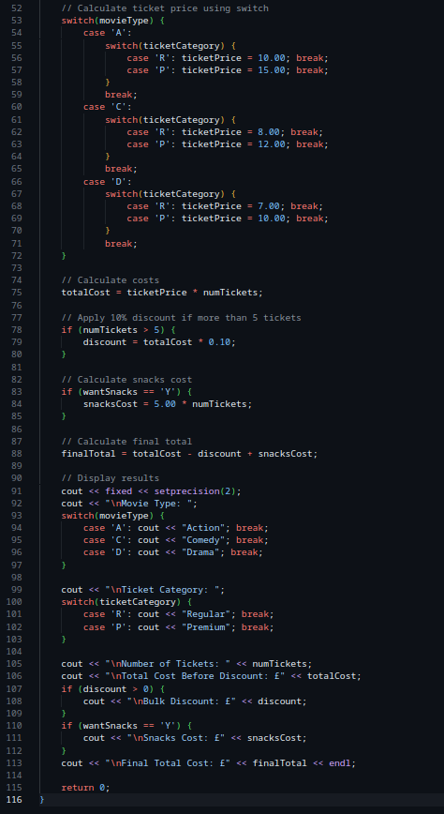

**Example output:**

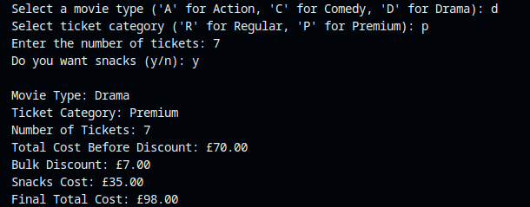

# Menu-Driven System with Validation

* Developed a looped menu with switch to allow multiple interactions:  
  + Option 1: Book Tickets
  + Option 2: View Ticket Prices
  + Option 3: Exit
* Input validation includes:  
  + Ensuring movie type is one of 'A', 'C', 'D'
  + Ensuring ticket category is 'R' or 'P'
  + Ensuring number of tickets > 0
* Implemented an option to view the ticket price chart.
* Provided a clean and clear booking summary after each transaction.

Implementation Code:

**Display menu code:  
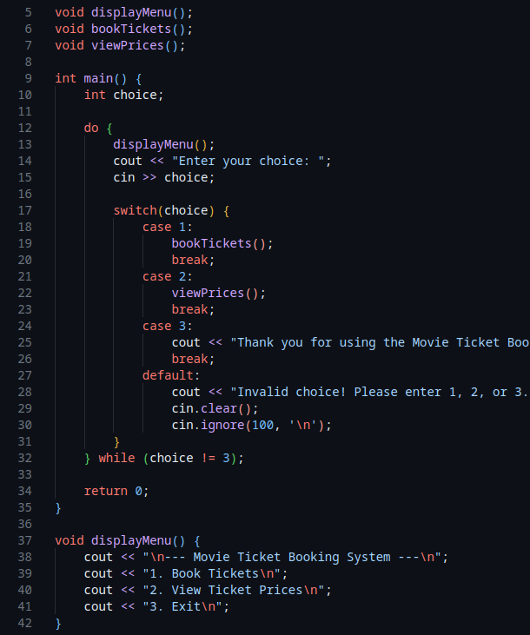**

**Prices, tickets and category code:  
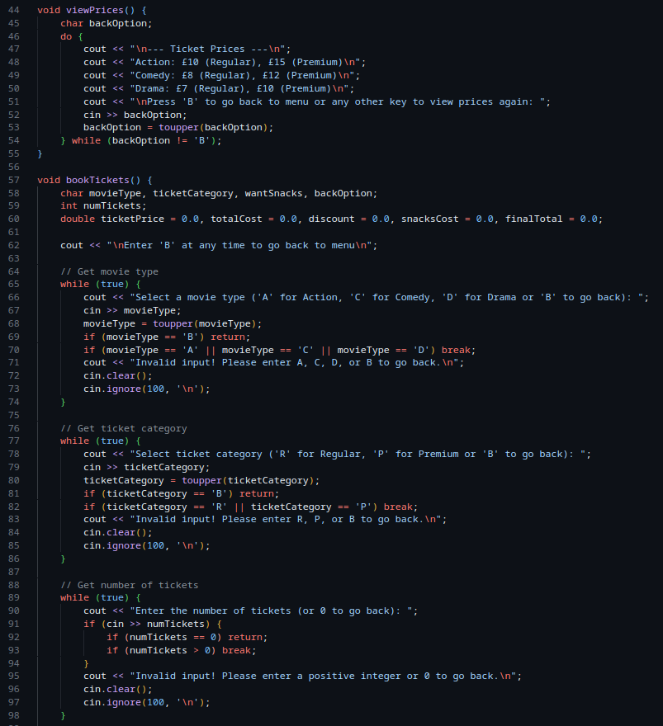**

**Final code (snacks, calculation and output code):**

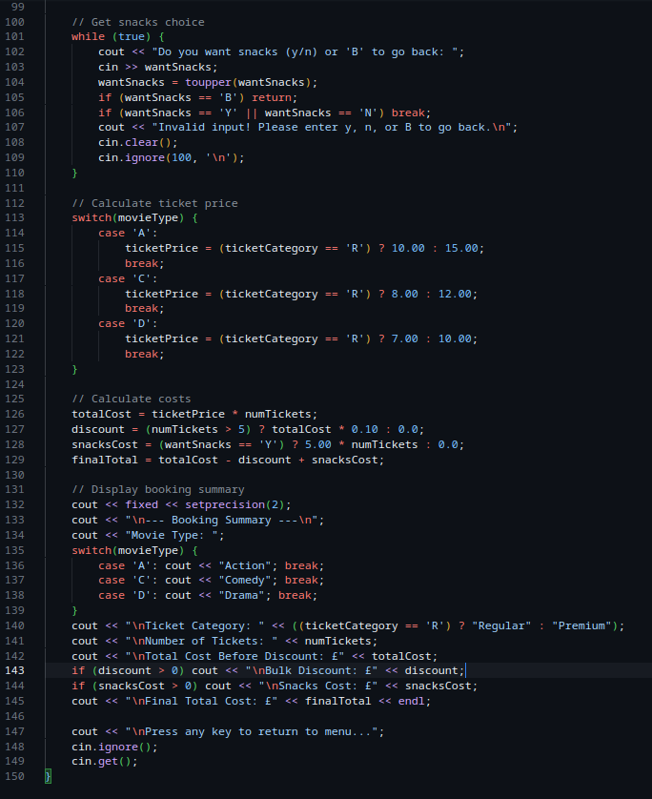

Example Output:  
